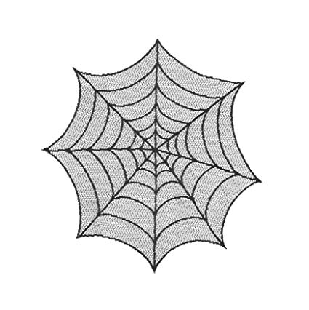



**INCY WINCY SPIDER**

THE INCY WINCY SPIDER

WENT UP THE WATER SPOUT.

DOWN CAME THE RAIN

AND WASHED THE SPIDER OUT.

OUT CAME THE SUN

AND DRIED UP ALL THE RAIN

AND THE INCY WINCY SPIDER

WENT UP THE SPOUT AGAIN.